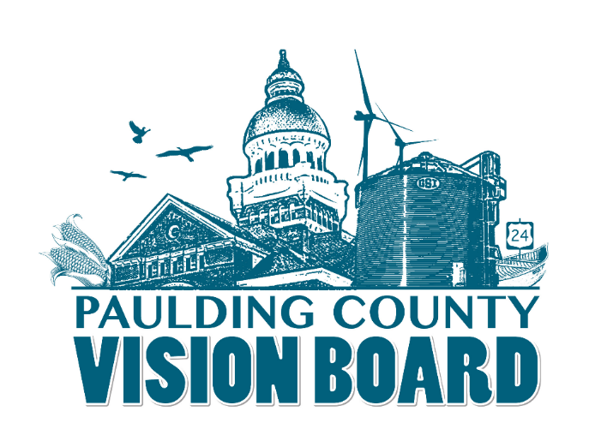
Paulding County Vision Board Minutes March 4th

Attendance:
The meeting opened at 3:23 pm.

Old Business:
Approval of Minutes February 4th, 2019

Minutes Approved.

- Update from Maumee Valley Planning (Ellen Smith)- No update from Ellen.
- Quality of Life Campaign Review (Those in attendance of special meeting)
Erika Willitzer recapped the special meeting

Commissioner Zartman reported that a corporation is wanting to donate an initial amount of 25k for our grant fund, but they are requested that we come up with a project. The company rep also suggested that we reach out to other potential donors, which the Marketing Committee has already discussed prior. The group decided that each community should identify a project with the focus of PARKS/RECREATION/QUALITY OF LIFE. We’ll market this as one BIG VISION…with all of us teaming up/collaborating to have MAJOR impact when it comes to quality of life. The hope is that each community will create its own grassroots campaign and in turn…this will feed into an entire county-wide grassroots campaign.
Examples could be upgrading parks, creating trails, a Visit Paulding County website that highlights our activities, expansion of river opportunities, creating a toboggan run, horseback riding trails…while it may seem like we’re focused on individual projects…the end result with all the projects combined… would be….we’ve developed PAULDING COUNTY INTO A SOUGHT AFTER DESTINATION and an attractive place for people to live.
Each community is to identify a special project/projects to be submitted to the Quality of Life Committee by March 15th. Erika will send out a Project Submission Form. Once approved, we will compile a county-wide list of all the projects throughout the county.
This doesn’t mean we will just hand out the funds once raised. We need to come up with a formula based on percentage, etc. where each community also must put some skin in the game.
The hard part of all of this is…the fact that EDP plans to break ground in April…this means we need to move fast on getting cost estimates, etc. for the projects.

Committee Reports
- Quality of Life (Chair -Erika to report) (John Daeger to review current park and rec. assets) (See Attached power point)
- Infrastructure (Chair – Sara) The board decided that it wants Sara to move forward with the infrastructure committee. If possible, a committee meeting before our next full board meeting was recommended.
- Housing (Chair – Aaron) Aaron agreed to chair. Dave Burtch and Bob Young also agreed to participate on this committee. Aaron stated that he plans to hold a meeting before our next full board meeting.
- Marketing (Chair – Erika and Joe) – The marketing committee has a fundraising flyer already ready for print. They will meet in the next two weeks to plan for the launch of our big campaign.

New Business:

No new business

A motion made by Dale Goebel to adjourn and seconded by John Daeger....Meeting Adjourned!

Next meeting April 1st, 2019

