Paulding County Vision Board Meeting December 3rd, 2018

Meeting called to order 3:20pm

October Minutes
**John Daeger made a motion to approve and Lisa McClure seconded...Motion approved.

OLD BUSINESS:
Ellen Report - (See Attached)
-First Dashboard Overall
-Creating Dashboard of Community Projects

Member Report:
-John Daeger (Broughton) informed the board that on Thursday, December 6th the Paulding County Land Bank initiated cleanup action on another dilapidated property. See below for exact goals being worked on.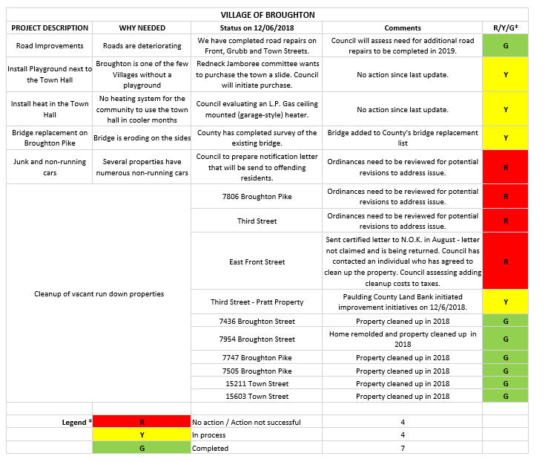

Deedi Miller (Oakwood) reported on the following projects: The old post office which is in poor condition will be torn down in the coming weeks. Also, Oakwood, is looking to replace green
sand filters prior to digging the new well which is slated for Sept 15 2019. The village is working with Artesian to replace green sand. The project funding will come from a Community Development Block Grant allocated in 2017. Also, Harmon street replacement and widening will start in late March or early April. Also, the ballpark ditch project is slated for early spring

Sara Keeran (Antwerp) reported the village of Antwerp was not awarded sidewalk funding for the south side of Antwerp near Dollar General. The village plans to re-submit their application to ODOT because their council thinks not having sidewalks on the southside is a hazard. The Ohio Department of Recreation received a grant to install 10 fitness trails by Riverside Park. The grant was funded by Paulding County Hospital in hopes of promoting healthy living. The project is expected to be completed this summer.

Aaron Timm (At Large) Timm works at the Paulding County Engineering Office and stated Auditor’s office and Engineering office have been working together to implement a GIS Mapping system county-wide. This program should be fully functional in two to three years.

David Burtch (At large/President) (Paulding) announced the village hired a new administrator. His name is Dale Goble. Dale will most likely take Ryan Mapes vacated seat on the Vision Board, pending approval. The village of Paulding has also selected a contractor for the third phase of the sewer-water separation project. This project will kick off in spring. Dave also mentioned that the swimming pool requires major repairs and the bridge on Garfield Extension is still out. The village is looking for funding options on these two projects. Dave also stated the Downtown Improvement District is looking to becoming a historical designation.

Shared Service Program
It was suggested that a meeting with all the Mayors and Administrations be held. The topic of discussion would a county-wide share service program. It was recommended that the Vision Board help facilitate this. This shared service program could be used to share costly equipment. More details to come.

Water Sewer District Discussion
It was deemed there wasn’t enough information or research conducted so the discussion was tabled.

Funding Survey Results

The Vision Board wants to begin looking into raising funding for the county where all organizations would have the opportunity to potentially apply. The suggested categories for a program are as follows:

- Establish a Facade & Beautification
- Establish a Workforce Development
- Establish an Incentive Program for Developers and Small Business Groups
- Parks and Recreation

It was decided that we create a program, should we raise funds that would allow organizations to fall in one or more of the categories listed above. The marketing committee will tackle creating application rules.

Marketing Committee Report
Chair of the Marketing Committee Erika Willitzer presented a rough draft of a donation request flyer to be circulated, so when we are ready to request funding, we’ll be ready.

Aaron Timm and Lisa McClure researched the possibility of hosting a balloon festival in Paulding County, in order to raise additional funds. This also could be held in conjunction with Paulding County’s 200th Anniversary. At a lot of research, it was deemed not feasible financially.

New Business
(none)
Next meeting will be held January 7th at the Antwerp Depot!

Meeting adjourned a motion made by John Daeger....Bob Young seconded...Meeting Adjourned.

###

